# Techno Machine Tools

Survey no:126/A/1, DOOR NO: 4-132-9/A/2, Gandimaisamma X Road,

Medchel Malkajgeri,Hyderabad-500043.Telangana, India.

(Mfg of bailing presses)

*T.SIVARAMAKRISHNA*

# ME.,MBA.

Ref:-TM/Chittoor/S0325/2025 18-06-2025

To

Mr. Bala  
Company : Spider birds Recycle.  
Mobile No :[+919444433298](tel:+919444433298)  
Email : [bala22india@gmail.com](mailto:bala22india@gmail.com)  
City : Chittoor  
State : Andhra Pradesh

# Dear Sir

SUB:-SUPPLYOFPAPERCARDBOARDBAILINGPRESS CONTINUESOPERATION

With reference to our discussions regarding your requirement of Card Board Bailing Press. We are glad to inform you that, we are in a position to supply you the required equipment. The following are the specifications and our terms and conditions.

# Specifications of the equipment

***Technical Specifications:-***

Max Working Pressure - 250Kg/cm2 Normal Working Pressure -200 Kg/cm2

Design Pressure - 250 Kg/Cm2 Tonnageat200 Kg/cm2 - 55Tons-2nos Cyl Bore - 180 mm

Rod Dia - 120mm Stroke - 1600 mm

Mtg - Front Flange

Approach Speed - 60mm/sec Return Speed - 120 mm/sec

HP - 75.0HP

TankCap - 2600Ltr

*Detail Bill of Material*

Cylinder Seals -Imported German Seals (Merkel or Halite)

Motor -ABB/Siemens /Kirloskar/Crompton

Rod Seal -Imported halite Seal

Valves -Yuken/Polyhedron/Hydro tech

Check Valves -Polyhedron

Hydraulic Pump -Yuken/Dowty

High PrPump -Polyhedron

BellHousing -Micro

Relief Valves -Polyhedron Hyd Tank - Micro

Hyd Tank - MHPL

Fitting -Hyloc/Hydair

Gasket -Champion

Fastners - TVS/LPS

Bale size: - (w)1120X(H)1050X(L)V

Bailing chamber size - (w)1120X(H)1050X(L)2400 Feeding hopper size- (w)1120 X (L) 1825

Body - ms fabricated

Bale weight - 1200–1600depends

Working pressure- 200 bar

|  |  |
| --- | --- |
| Drive | - |
| Tying cylinders | - |
| No of ties | - |
| Wire size | - |
| Baldes | - |
| Hopper | - |
| Oil tank capacity | - |
| Operation | - |
| Chiller | - |
| Conveyer |  |
| Drive | - |
| Belt | - |
| Belt width | - |
| Speed | - |

75HPAND&7.5HP

provided 4 nos

3.24-4mm

provided provided

2600lts(in buyers scope) plc

Buyers scope

7.5 hpslat chain 1800 mm variable

|  |  |  |
| --- | --- | --- |
| **S No** | **Description of the unit** | **Offer/unit** |
| 1. | Continues cardboard bailing machine with complete automatic along with above specifications | **Rs 55,00,000/-**  (Fifty five Lakhs Only) |

GENERAL TERMS & CONDITIONS:

1. Price quoted per unit ex-work. Hyderabad.
2. Following charges are additional to your account.

* Freight Charge : As actual to be borne by you.
* Sales Tax : 18% Extra as applicable
* Packing charge : As actual to be borne by you.
* Insurance : As actual to be borne by you.

1. Payment : 50% advance along with order balance before delivery but after inspection at our works.
2. Delivery : Within 1 months from date of advance received
3. Validity : One month from the date of submission.
4. Inspection : Inspection at our works prior to dispatch.
5. Warranty : The machine is warranted for a period of 12 months from the date of dispatch against any manufacturing defects/ faulty material or bad workmanship of any part or component but not against any kind of abnormal or improper use of machine. Defective part or component will be replaced or repaired free of cost. Electrical components are outside the scope of this warranty.
6. Commissioning : Erection & commissioning done by you, but required technical support & guidance provide by us at additional cost.

NOTE:

1. Oil is not in scope of our supply.
2. Raw material for trial is to be arranged by you at your cost.

We are sure you will find our offer in line with your requirements. Should you require any further clarification please contact T.SIVARAMAKRISHNA 9246221106/9849207176 emil: techno9246221106@gmail.com

Thanking you and assuring you of our best services.

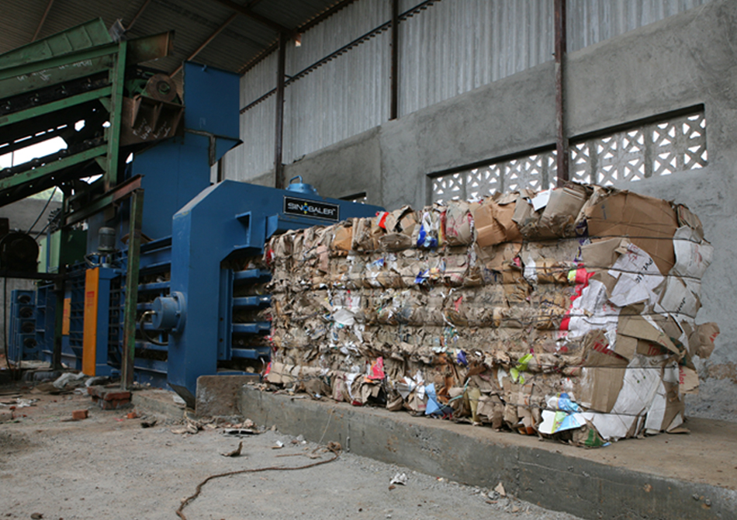

**For TECHNOMACHINETOOLS ( T. SIVARAMAKRISHNA)**